Security Operations Center (SOC) Lab Report

- Introduction:-
- In today’s digital environment, organizations face various cyber threats such as unauthorized access, malware, and data breaches. A Security Operations Center (SOC) is responsible for monitoring systems and detecting such threats in real time.
- The purpose of this lab was to understand how SOC works and to perform basic security monitoring tasks using tools like Wireshark, Windows Event Viewer, and browser analysis tools. This helped in gaining practical knowledge of detecting suspicious activities.

- SOC Fundamentals and Operations:-
A SOC is a centralized unit that monitors network and system activities continuously. Its main goal is to detect and respond to security incidents before they cause damage.
Different roles in a SOC include:-
- Tier 1 analysts who monitor alerts
- Tier 2 analysts who investigate incidents
- Tier 3 analysts who perform advanced threat hunting
- SOC manager who supervises the operations
The main activities of a SOC include log monitoring, alert analysis, and incident response.

- Security Monitoring Basics:-
Security monitoring involves observing system and network activities to detect anomalies or unauthorized access.
The main objectives are:-
- Detect unusual behavior.
- Identify unauthorized access.
- Ensure policy compliance.
Tools used:-
- Wireshark for network traffic analysis.
- SIEM tools like Splunk and Elastic (conceptual understanding)
Key metrics include:-
- False positives and false negatives.
- Mean Time to Detect (MTTD).

- Log Management Fundamentals:-
Logs are records of system activities and are essential for identifying security incidents.
The log lifecycle includes:-
- Collection.
- Normalization.
- Storage.
- Analysis.
Common log types:-
- Windows Event Logs.
- Syslog.
- HTTP logs.
In this lab, logs were analyzed using Windows Event Viewer to detect failed login attempts.

- Basic Security Concepts:-
In cybersecurity, some fundamental concepts are used to ensure the protection of systems and data. One of the most important models is the CIA Triad, which represents the three core principles of security.
- Confidentiality:-
Confidentiality ensures that sensitive information is protected from unauthorized access. Only authorized users should be able to view or access the data. This is achieved using methods such as encryption, authentication, and access control.
- Integrity:-
Integrity ensures that data remains accurate and is not altered or modified by unauthorized users. It guarantees that the information is reliable and trustworthy. Techniques such as hashing and digital signatures are used to maintain data integrity.
- Availability:-
Availability ensures that systems and data are accessible to authorized users whenever needed. This includes maintaining system uptime and protecting against disruptions such as server failures or cyber attacks like Denial of Service (DoS).

- Threat vs Vulnerability vs Risk:-
In cybersecurity, it is important to understand the difference between threat, vulnerability, and risk, as they are closely related concepts.
- Threat refers to a potential attack or harmful event that can exploit a system. For example, a hacker attempting to gain unauthorized access.
- Vulnerability is a weakness or flaw in a system that can be exploited by a threat. This could be due to outdated software or poor security configurations.
- Risk is the possibility of damage or loss when a threat exploits a vulnerability. It depends on both the likelihood of the attack and its impact.

- Security Operations Workflow:-
In a Security Operations Center (SOC), incidents are handled through a structured workflow. This workflow helps in detecting, analyzing, and responding to security threats efficiently.
The typical SOC workflow includes the following steps:-
- Alert Generated:-
A security alert is triggered by tools such as SIEM, IDS, or antivirus systems.
- AlertTriage:-
The alert is analyzed to determine whether it is a real threat or a false positive.
- Investigation:-
Detailed analysis is performed using logs and other data sources to understand the issue.
- Containment:-
The threat is isolated to prevent further damage.
- Eradication:-
The root cause of the threat is removed from the system.
- Recovery:-
Systems are restored to normal operation.
- Tools Used:-
The following tools were used:-
- Wireshark.
- Windows Event Viewer.
- LECmd (browser history tool).
- Snort (conceptual).
- Kibana (conceptual).
- Security Tools Overview:-
Various tools are used in SOC environments:-
- SIEM: Splunk, QRadar.
- EDR: CrowdStrike.
- IDS/IPS: Snort.
- Vulnerability Scanner: Nessus.
Practical understanding included writing a Snort rule to detect malicious HTTP traffic and basic awareness of vulnerability scanning.

- Practical Implementation:-
9.1. Log Analysis using Event Viewer:-
Windows Event Viewer was used to check security logs. Event ID 4625 was filtered to detect failed login attempts.
Multiple failed login attempts were observed within a short time, which indicates suspicious activity.
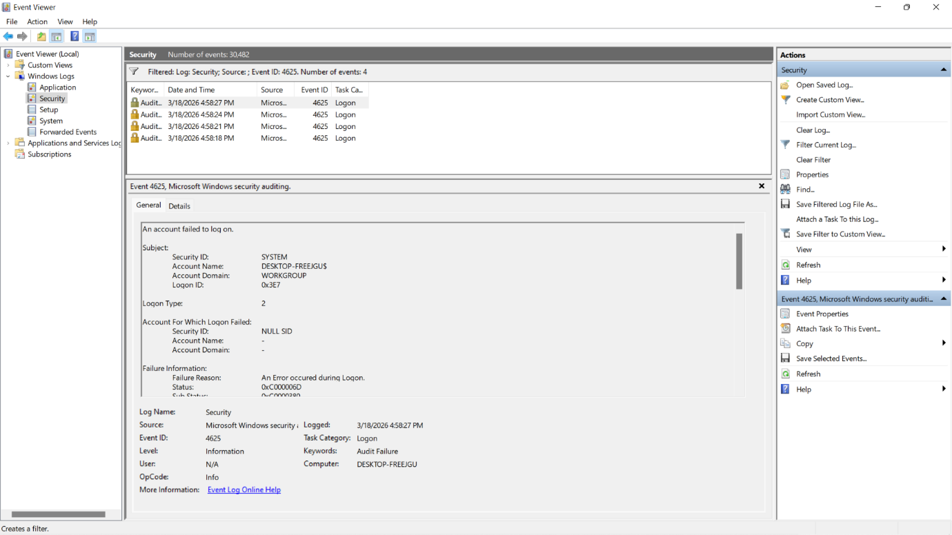
Fig: 1- Failed login attempts (Event ID 4625) in Windows Event Viewer
9.2. Brute Force Attack Simulation:-
- A brute force attack was simulated by entering incorrect passwords multiple times.
- It was observed that the same user account was targeted repeatedly within seconds. This pattern confirms a brute force attempt.
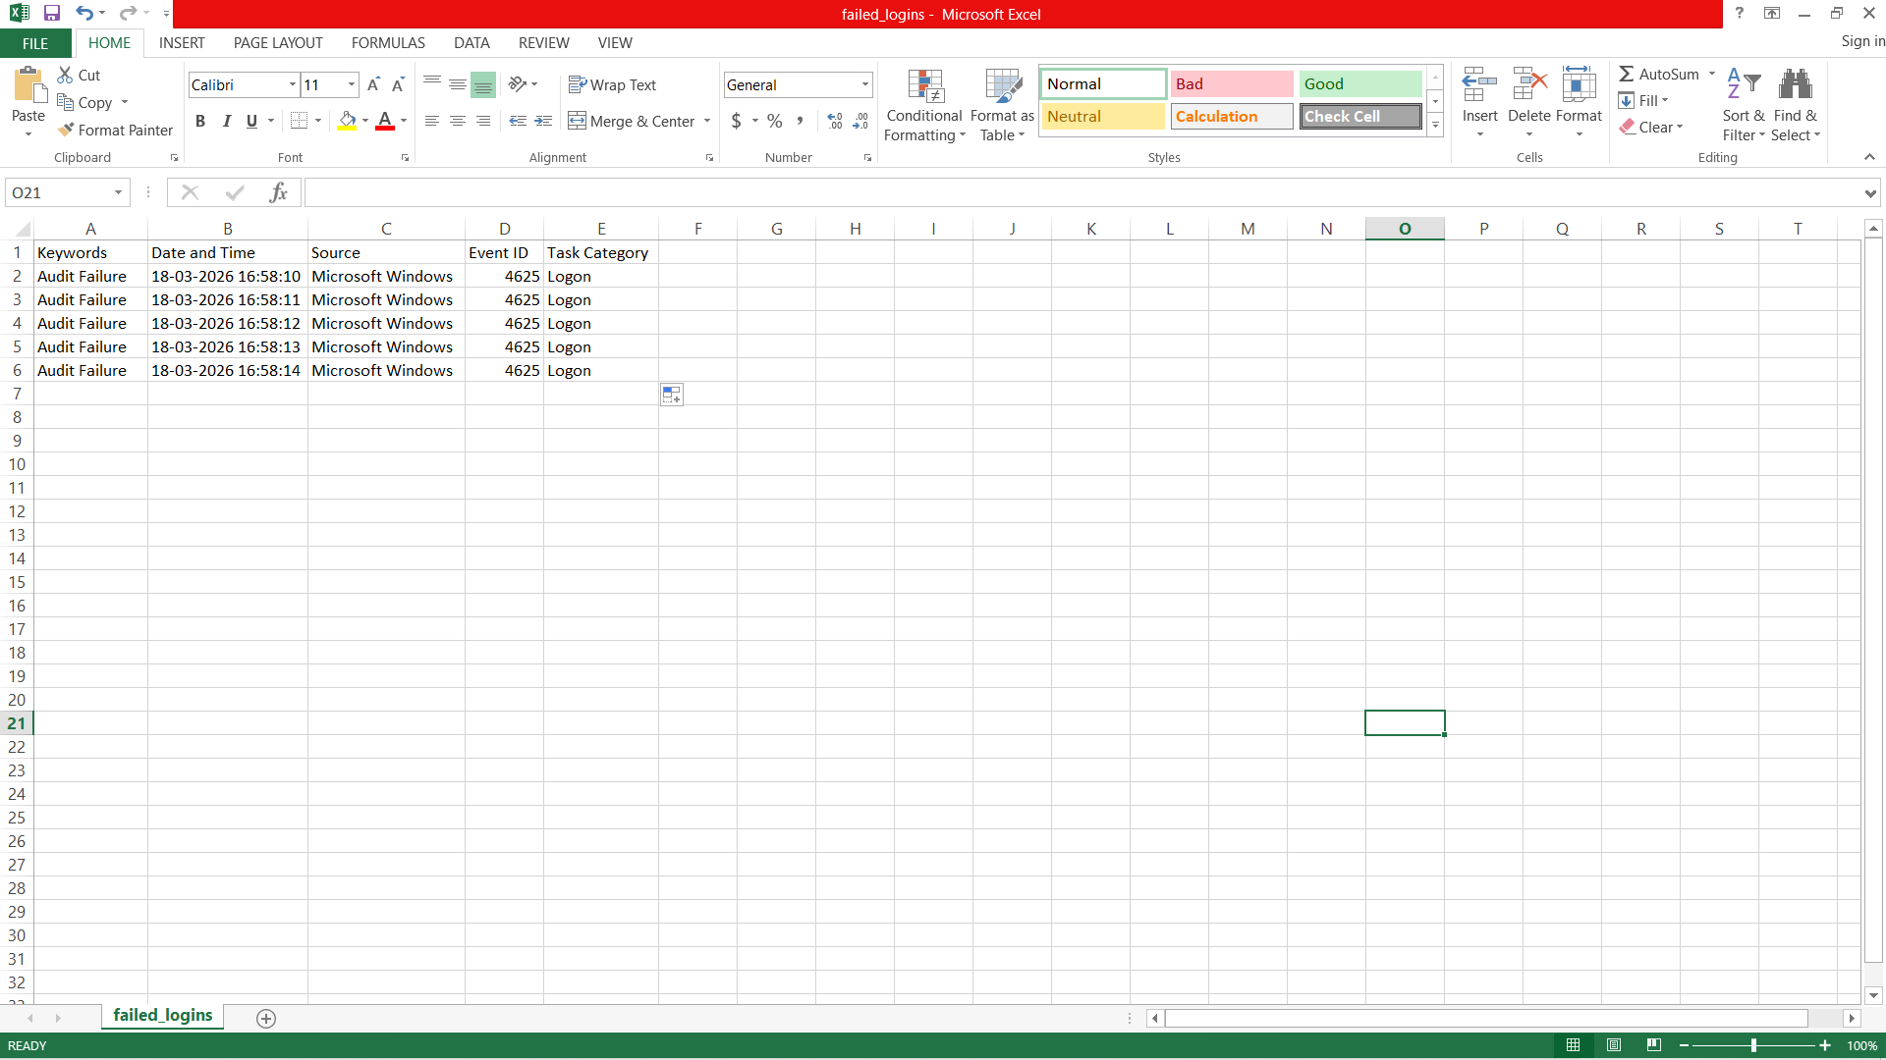
Fig: 2- Repeated failed login attempts indicating brute force attack

9.3. Browser History Analysis:-
- Browser history was analyzed using the LECmd tool. The Chrome history file was extracted and examined.
- Visited websites and timestamps were observed to identify any suspicious browsing activity.
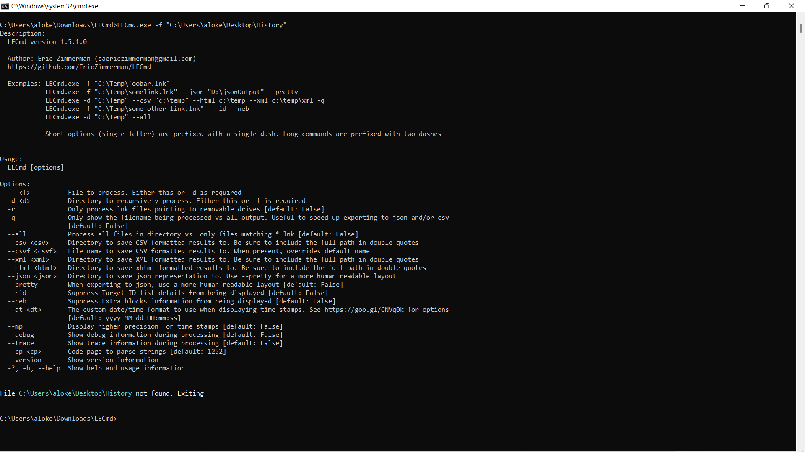
Fig: 3- Browser history extracted using LECmd tool
9.4. Network Traffic Analysis (Wireshark):-
- Wireshark was used to capture and analyze network traffic.
- An external IP address was observed communicating with the local system. External communication is important to monitor in SOC environments.
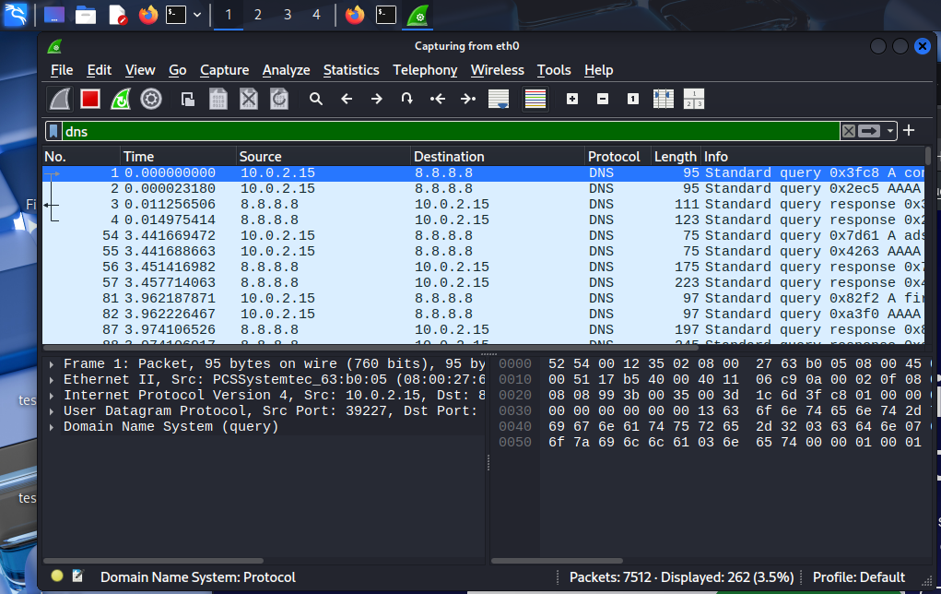

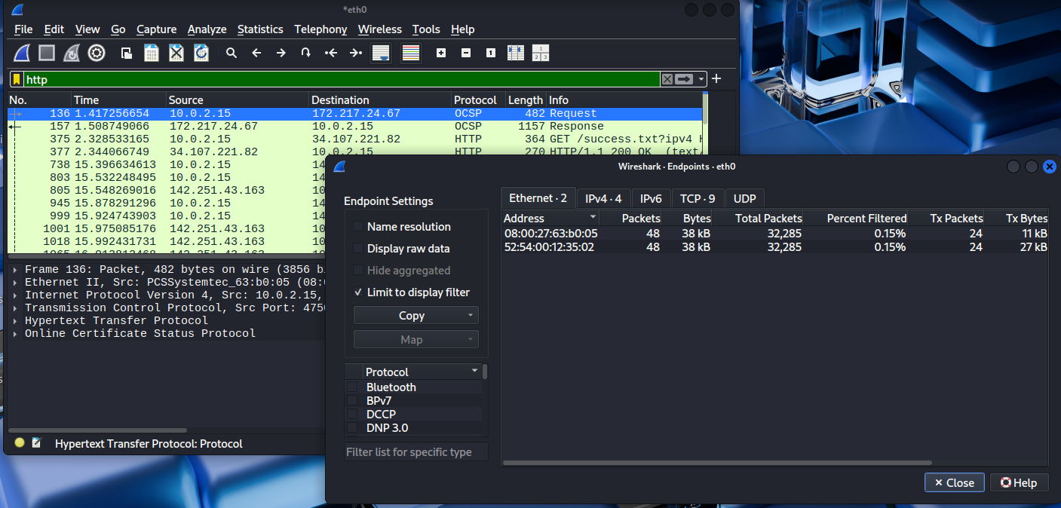

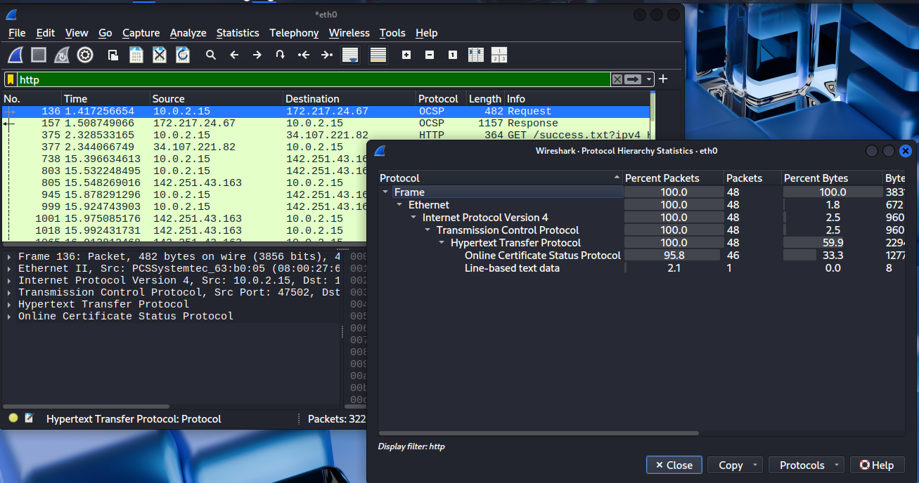
Fig: 4- Network traffic showing external IP communication

9.5. Security Event Documentation:-

Date | Source IP | Event ID | Description | Action Taken
18-03-2026 | 10.0.2.15 | 4625 | Multiple failed login attempts | Monitored

10. Monitoring Dashboard (Conceptual):-
Kibana dashboards are used to visualize:-
- Top source IPs.
- Failed login attempts.
- Critical alerts.
Due to system limitations, this was studied conceptually.



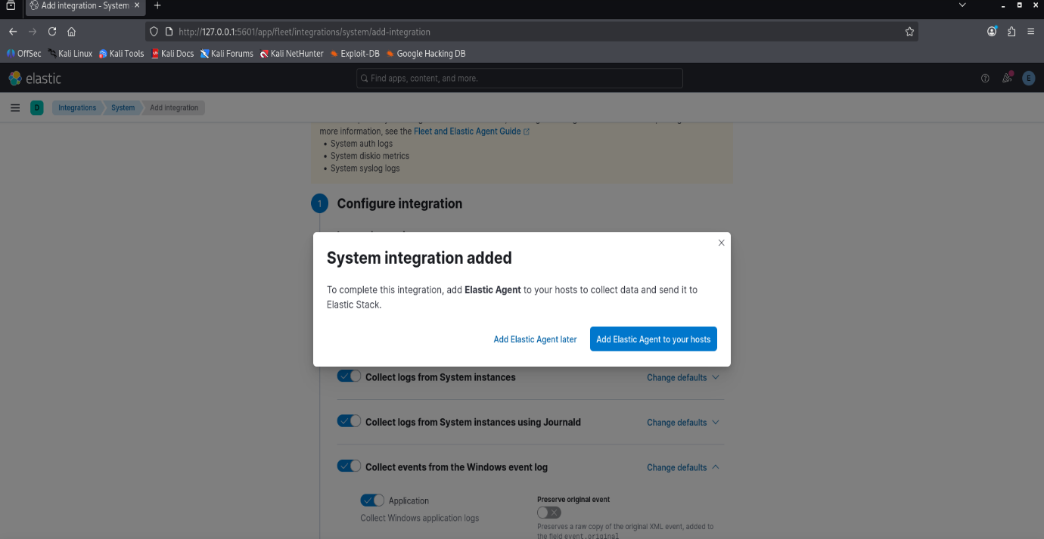
Fig: 6- Example of Kibana dashboard
11. Alert Rule Configuration:-
An alert rule was defined:-
- Detect 5 failed login attempts in 5 minutes
Logs confirmed multiple failed attempts, satisfying the condition.
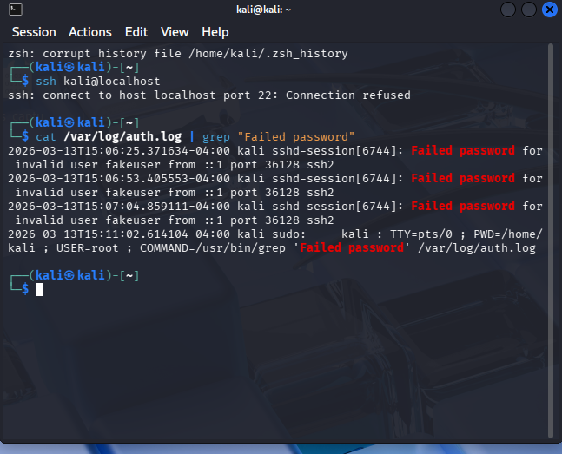
Fig: 7- Failed SSH Logins

11. Documentation Standards:-
Documentation is important in SOC for maintaining records of incidents.
Examples include:-
- Incident reports.
- Runbooks.
- SOPs.
Proper documentation ensures better analysis and response in future incidents.

12. Challenges Faced:-
During the lab, several challenges were encountered:-
- td-agent could not be installed in Kali Linux.
- Virtual machine performance issues.
- Tool configuration difficulties.

13. Conclusion:-
- This lab provided a clear understanding of SOC operations, including monitoring, detection, and response to security incidents.
- Practical tasks such as log analysis, brute force detection, and network monitoring helped in gaining hands-on experience. Overall, this lab strengthened the understanding of cybersecurity concepts and tools used in real-world SOC environments.

